2015+ Geely Atlas Pro Normal Threshold Install Manual

BOM List
# | Component Name | Qty | # | Component Name | Qty
⑴ | 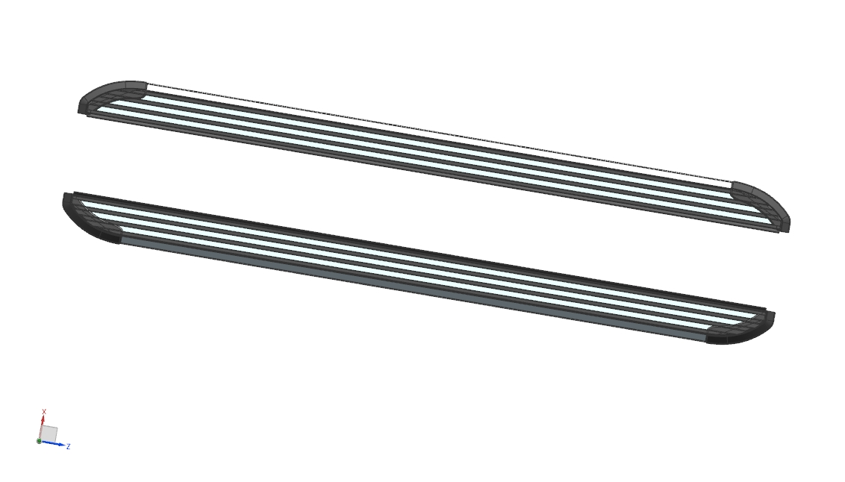  Pedal (left and right symmetry)  2 pcs | 2 | ⑵ | 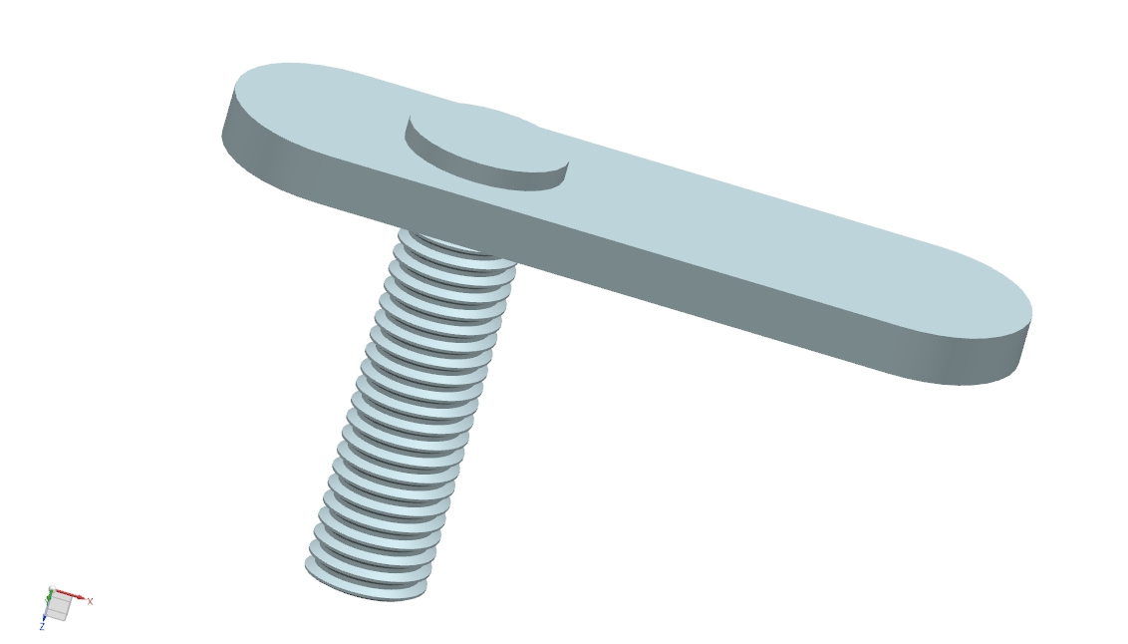  Welding flat head screw M10(Large） | 4
⑶ | 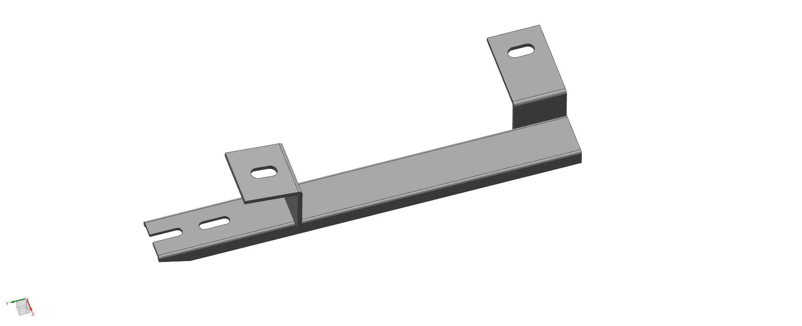Front Bracket (left and right symmetry) | 2 | ⑷ | Welding flat head screw M10（Small） | 2
⑸ | 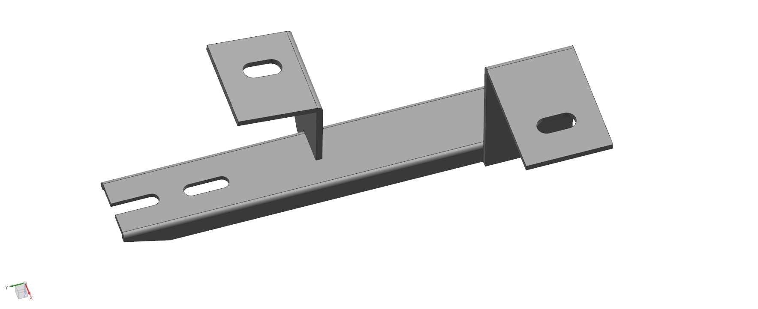  Left Rear Bracket (left and right symmetry) | 2 | ⑹ | Welding flat head screw M8 | 8
⑺ | 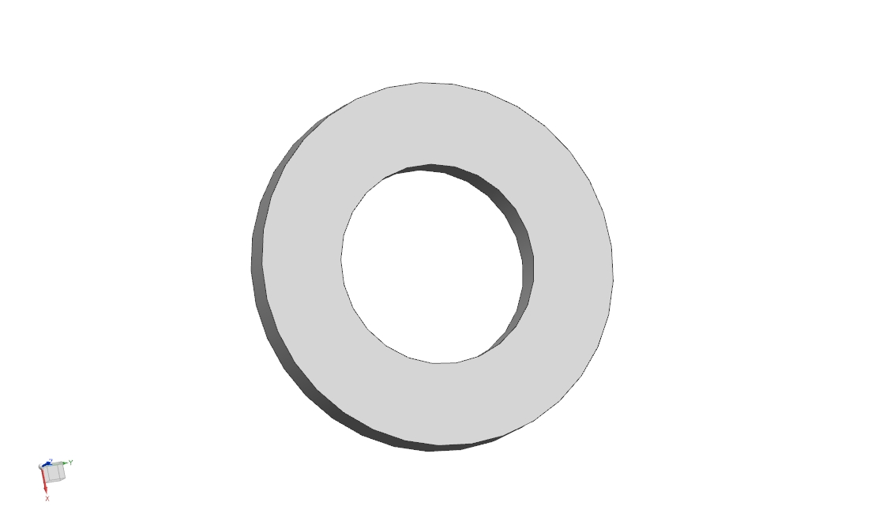  Flat Pad D10 | 6 | ⑻ | Flat Pad D8 | 10
⑼ | 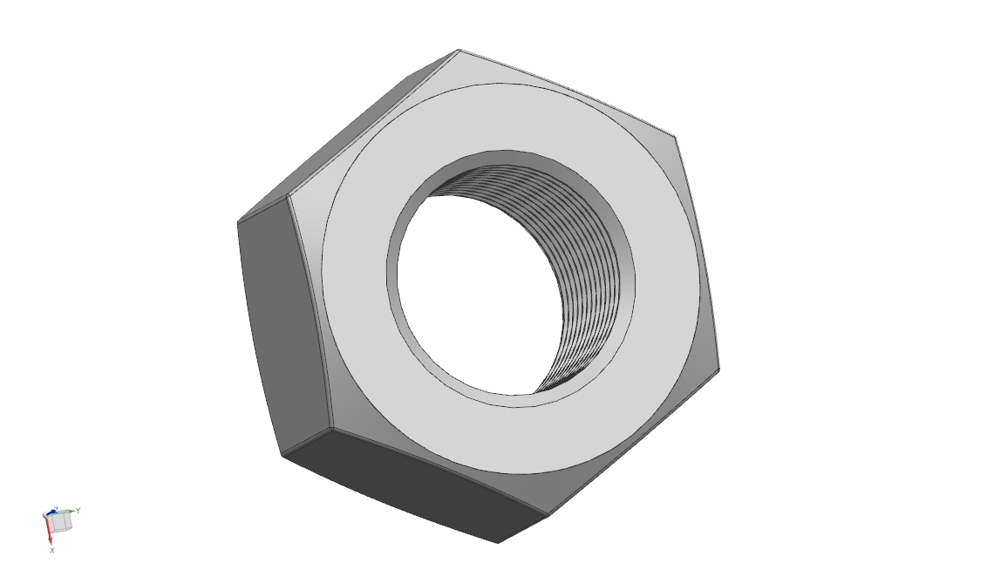  External Hexagon Nut M10 | 6 | ⑽ | External Hexagon Nut M8 | 2
⑾ | 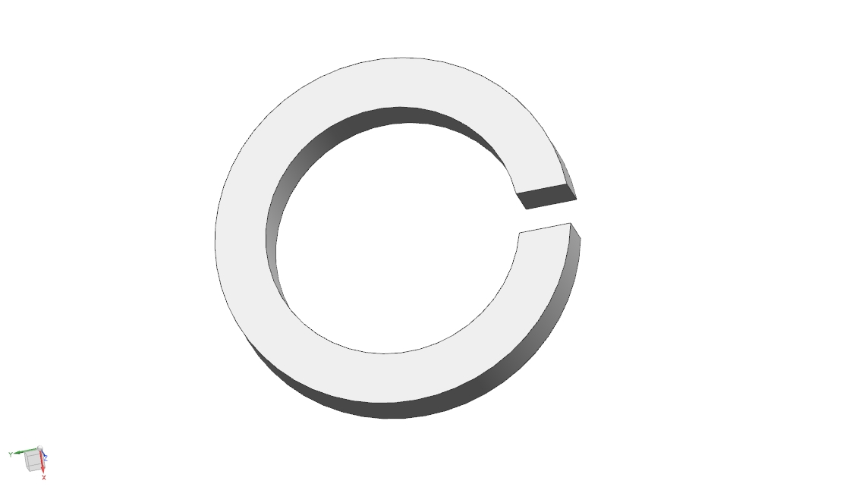  Spring Pad ￠10 | 6 | ⑿ | Spring Pad￠8 | 10
⒀ | 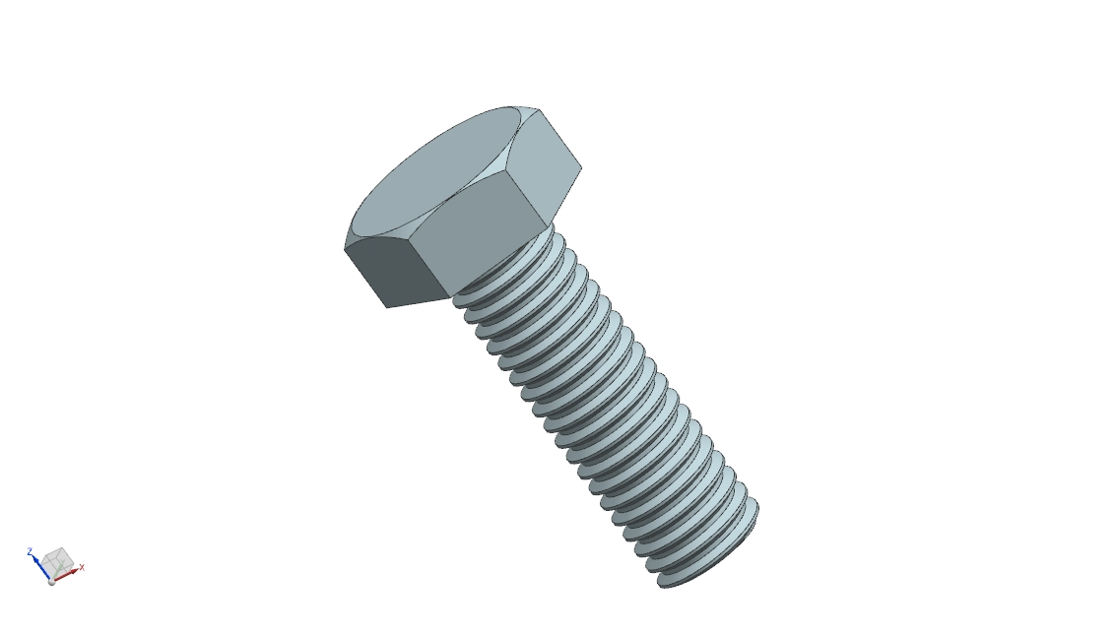  External Hexagon Screw M8 | 8 | ⒁

三.Installation Instruction（Left and Right side are same）
(1)

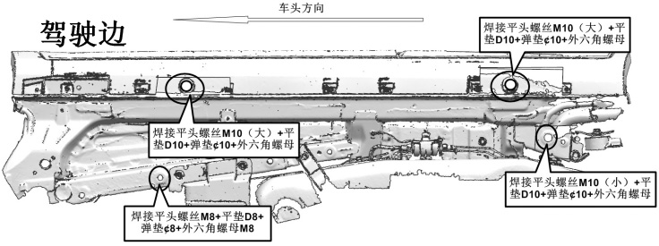
Driving Room Side
Car Hear Direction
- (7) (9) (11)
（2） (7) (9) (11)
（4） (7) (9) (11)
（6） (8) (10) (12)
(2)Install the fixed support: remove the corresponding screw plug of the original car, and then place the welding flat head screws in the corresponding holes to lock the corresponding support. (Left and right installation method is the same)
Driving Room Side
Car Hear Direction
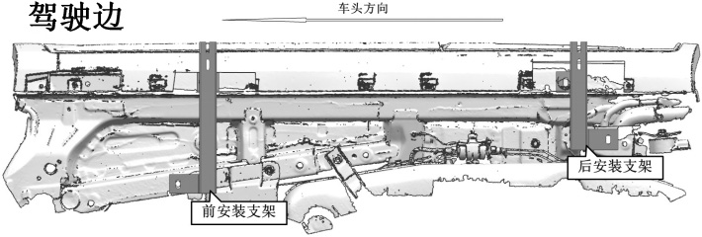
Front Bracket Install Position
Rear Bracket Install Position

（3） Install pedal (same install method for left to right)
After the fixing support is installed, place the pedal on the fixing support and lock the upper hole with outer hexagonal screws M8, flat pad D8, and spring pad D8.
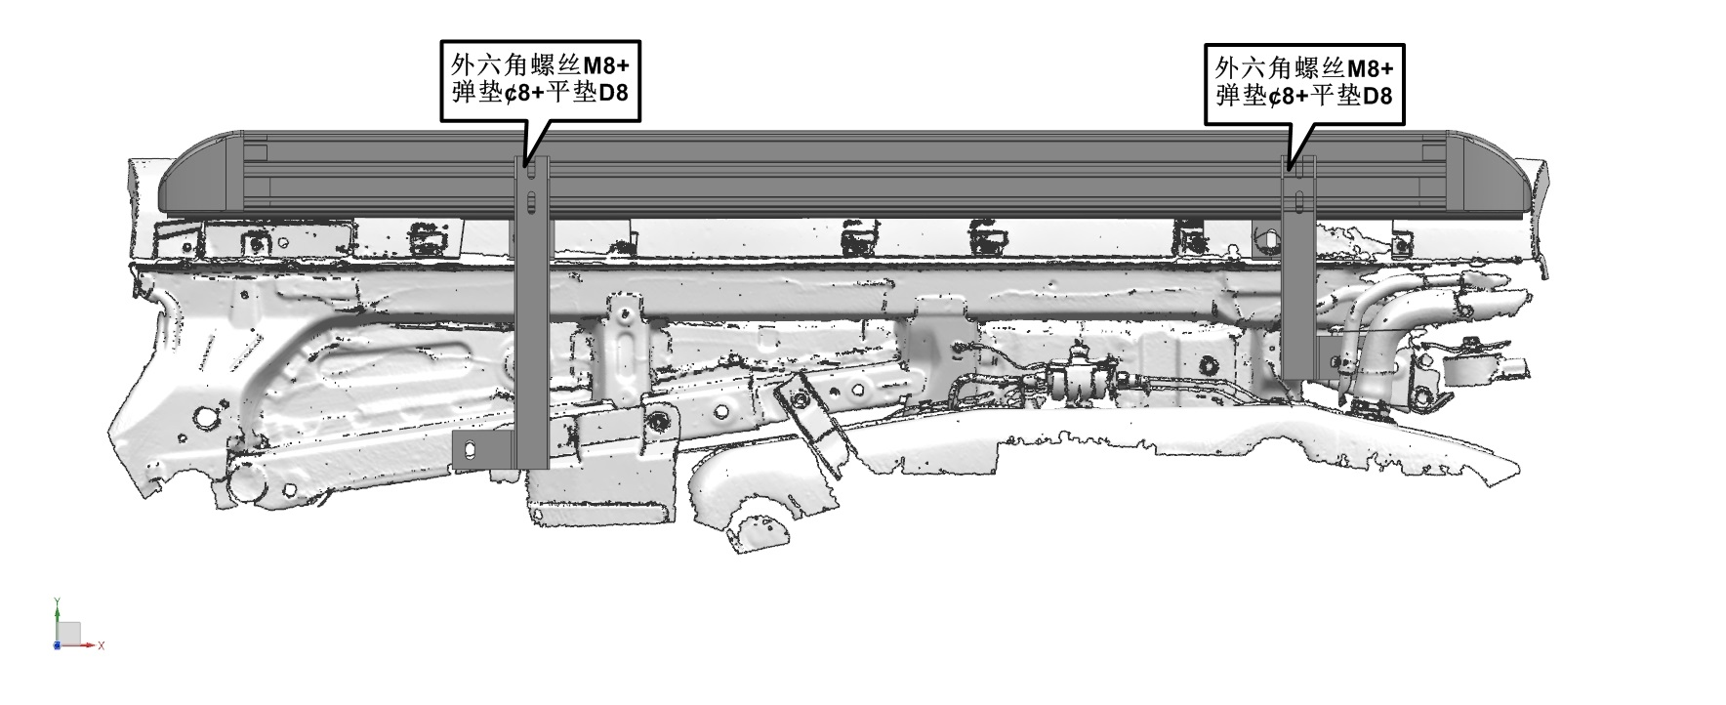
(8) (12) (13)
(8) (12) (13)
四．Test
- See if it's parallel to the car.
- After confirming that the pedal is completely OK, do not forget to check whether the nut on the pedal is completely tightened. After the nut is completely tightened, the original car protection plate is finally installed back. If there is interference between the car bottom protection plate and the pedal support, please trim the interference between the support and the original car protection plate to ensure that the original car protection plate is successfully installed back.

