Ford Explorer fixed Threshold installation instructions
Bracket installation instructions
- Precautions
1.. All pictures in this manual are for reference only. The pictures may be different from the actual objects. The installation method is the same.
2. In order to facilitate your installation, please read the product instruction manual carefully before installation. During installation, you need to protect the surface of your car to avoid scratches.
3. Regularly check whether all accessories connected to the car are loose to ensure safe use.
- Parts List
serial number | Accessories | quantity | serial number | Accessories | quantity
⑴ | 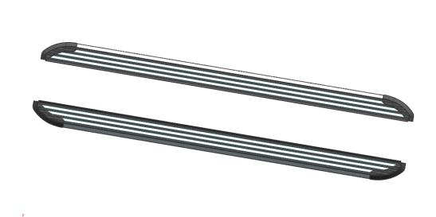  Pedal (left and right symmetry) | 2 | ⑵ | 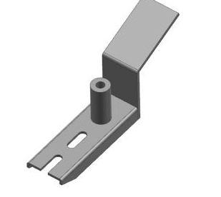  Middle bracket (left and right symmetry) | 2
⑶ | 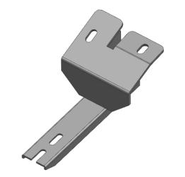  Front bracket (left and right symmetry) | 2 | ⑷ | 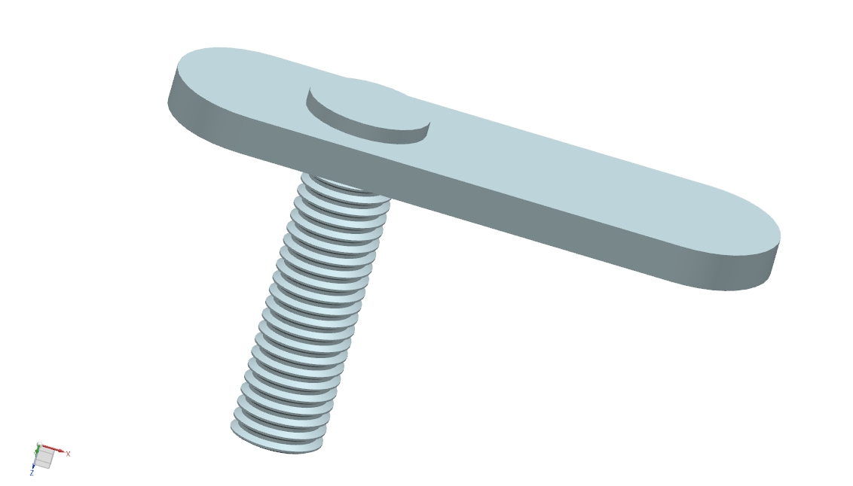  Welding flat head screw M10 (large size) | 2
⑸ | 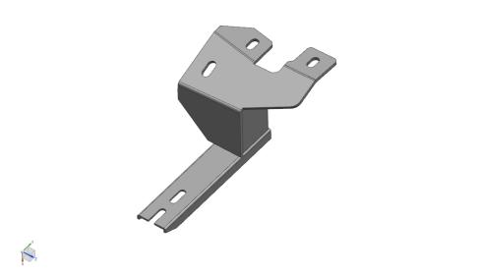  Rear bracket (left and right symmetry) | 2 | ⑹ | Welding flat head screw M10 (small size) | 4
⑺ | Welding flat head screw M8 (large size) | 2 | ⑻ | Welding flat head screw M8 (small size) | 2
⑼ | 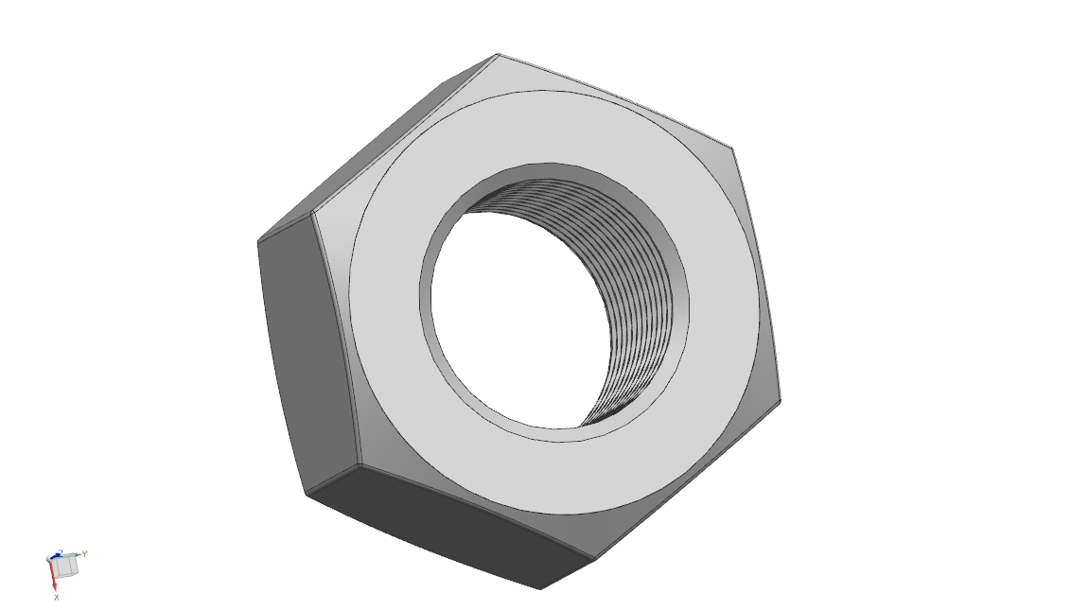  External hexagon nut M10 | 6 | ⑽ | External hexagon nut M8 | 6
⑾ | 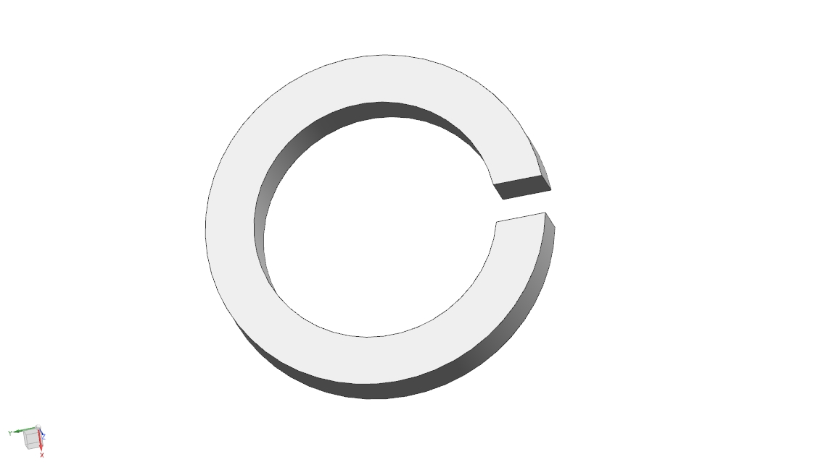  Spring pad ￠10 | 4 | ⑿ | Spring pad ￠8 | 18
⒀ | 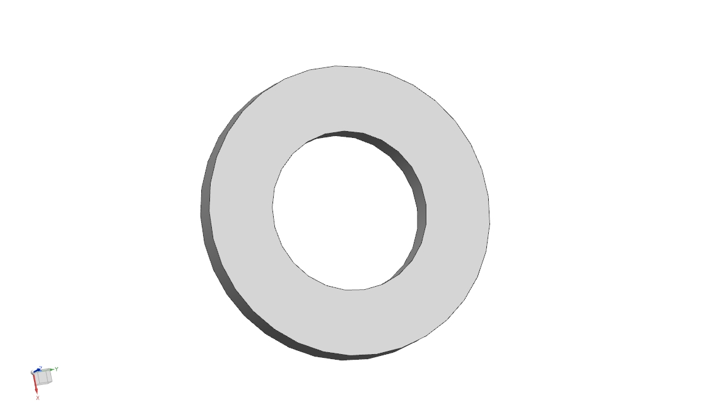  Flat pad D10 | 6 | ⒁ | 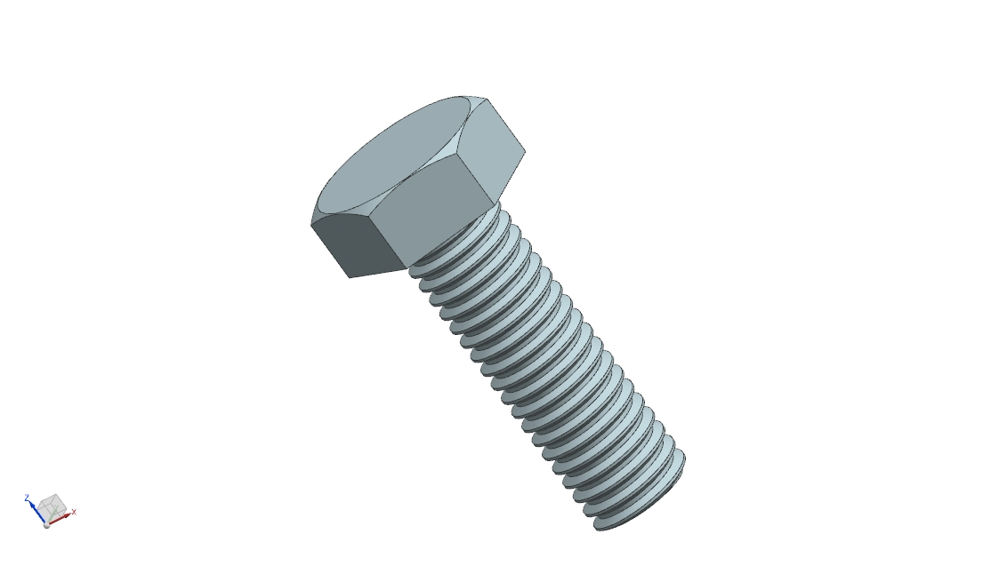  External hexagonal screw M8 | 12
⒂ | Flat pad D8 | 18 | ⒃ | 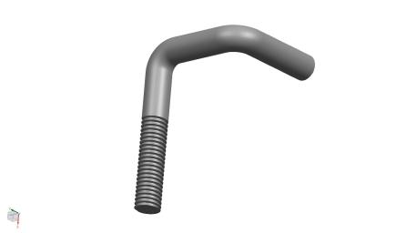  Hook screw M | 12
- Installation steps and methods (the installation methods on the left and right are the same, only the installation method on one side is described now)
- Bottom mounting hole location map:
Car Hear Direction

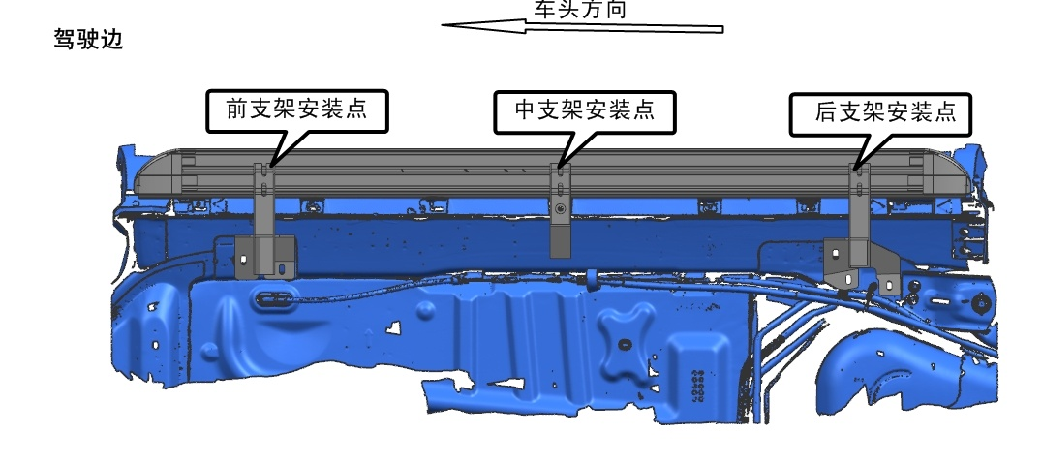
Front Bracket assembl position
Middle Bracket assembl position
Rear Bracket
assemble position
(2) Install the fixed bracket: Remove the corresponding screw plugs of the original car, then place welding flat-head screws in the corresponding holes, and install the corresponding brackets on the car and lock them. (The installation methods on the left and right are the same)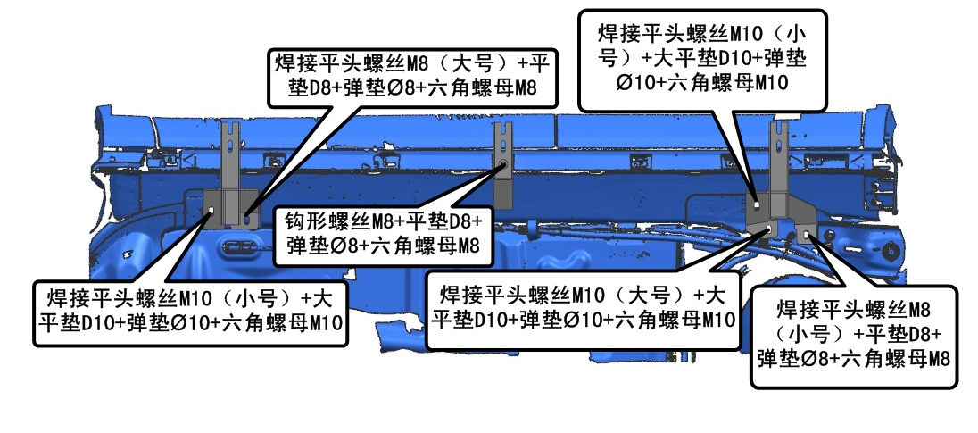
8， 15 ，12，10
6， 13 ，11，9
6， 13 ，11，9
6， 13 ，11，9
16，15，12，10
7， 15 ，12，10
(3) Install the pedals (the left and right installation methods are the same)
After the installation of the fixed bracket is completed, place the pedal on the fixed bracket bracket and tighten it with M8 external hexagonal screws, D8 flat washers and D8 elastic washers at the upper holes.
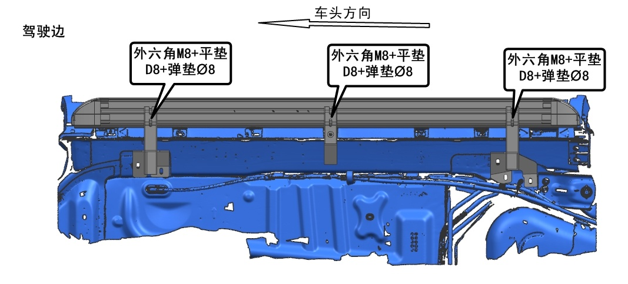
15，12，10
15，12，10

