Инструкция по установке порогов GAC GS8 22-

⑴ | 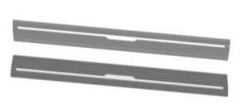  Pedal (left and right symmetry)  2 | ⑵ | 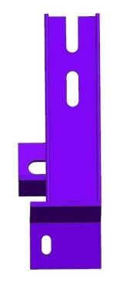  Left front bracket 2 pieces (symmetrical) | ⑶ | 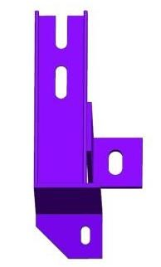  Left middle bracket 2 pieces (symmetrical)
⑷ | 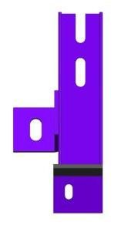  Left and right brackets  2 pieces (symmetrical) | ⑸ | 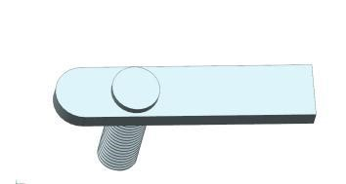  Welding flat head screw  M10X35 6 | ⑹ | 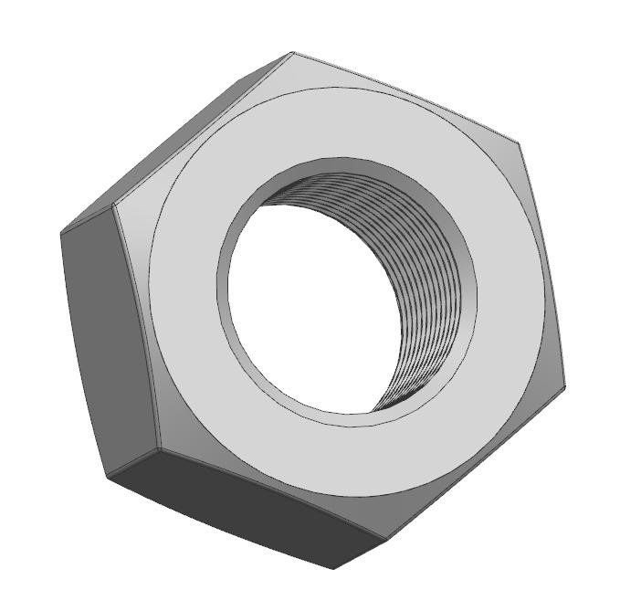  External hexagon nut M 10  6
⑺ |   Spring gasket D10  6 | ⑻ | 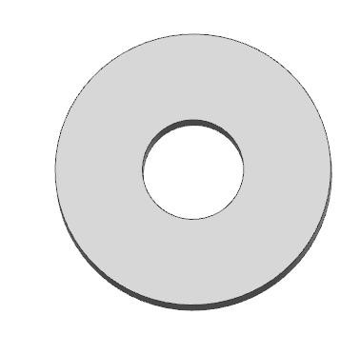  Flat gasket D 10  6 | ⑼ | 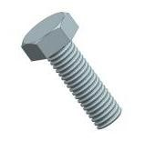  External hexagonal screw M  8X20  12 pieces
⑽ |   Spring gasket D8  12 pieces | ⑾ | 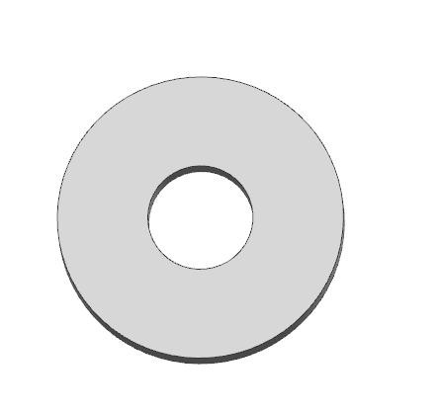  Flat gasket D 8  12 pieces | ⑿ | 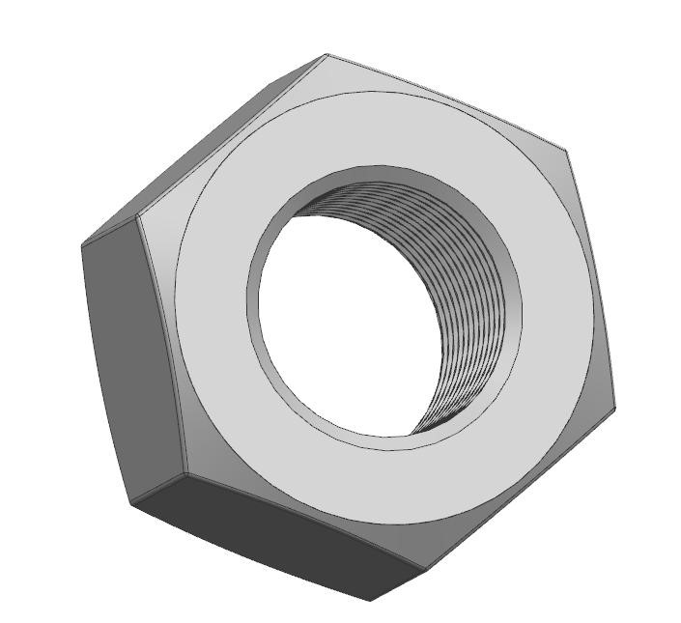  External hexagon nut M 6  6
⒀ |   Spring gasket D6  6 | ⒁ | 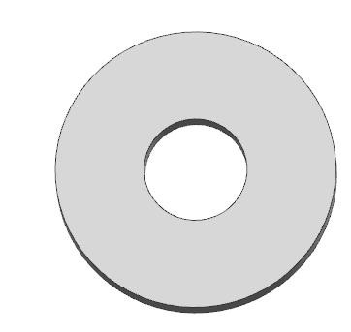  Flat gasket D 6  6 | ⒂

Rear Bracket install Position
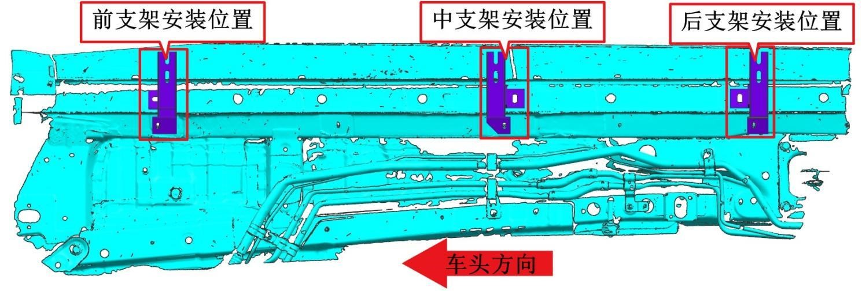
Schematic diagram of bracket position installation
Front Bracket install Position |  | Middle Bracket install Position

Driving side bracket installation accessories diagram (left and right symmetry):
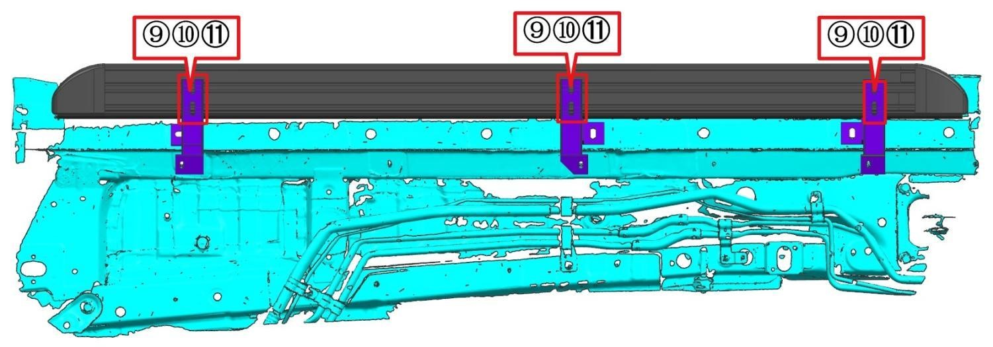
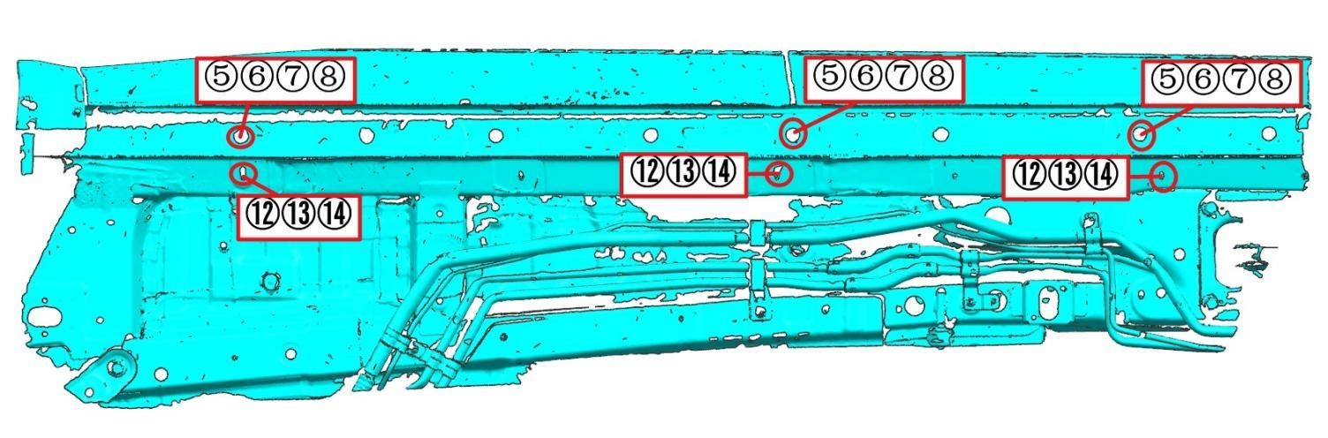Schematic diagram of pedal/transmission structure installation (left and right symmetry):

Магазин автотюнинга и автоаксессуаров Тюнинг Мастер
Наш адрес: Россия, Москва, МКАД, 55-й километр, с31, ТК Автомолл, Модуль 6
Телефон для связи: +7 (495)7490009, моб.+7(903)5490009
Электронная почта: tuningmaster@bk.ru

