Инструкция по установке порогов
Chery Exeed RX (2023-)

Parts List :

⑴ | 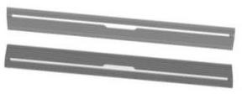  Pedal (left and right symmetry)  2 | ⑵ | 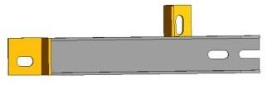  front bracket  2 pieces (symmetrical) | ⑶ | 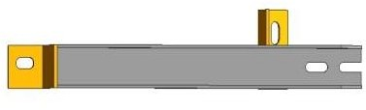  middle bracket  2 pieces (symmetrical)
⑷ | 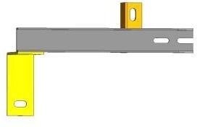  rear bracket  2 pieces (symmetrical) | ⑸ | 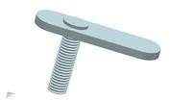  Welding flat head screw M10  *35  10 pieces | ⑹ | 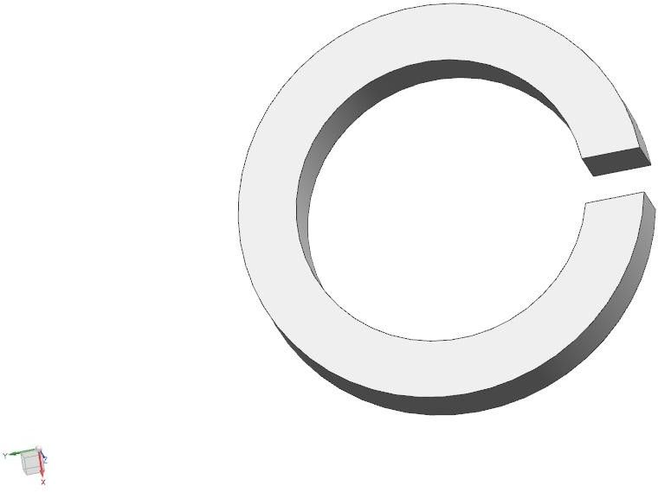  Spring pad D10 10 pieces
⑺ | 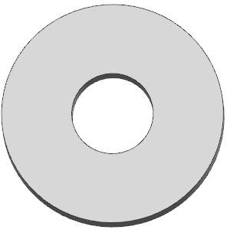  Flat pad D 10 10 pieces | ⑻ | 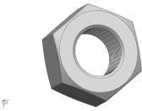  External hexagon nut M 10 10 pieces | ⑼ | 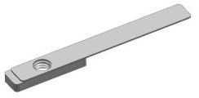  Rectangular nut block M 8  2
⑽ | 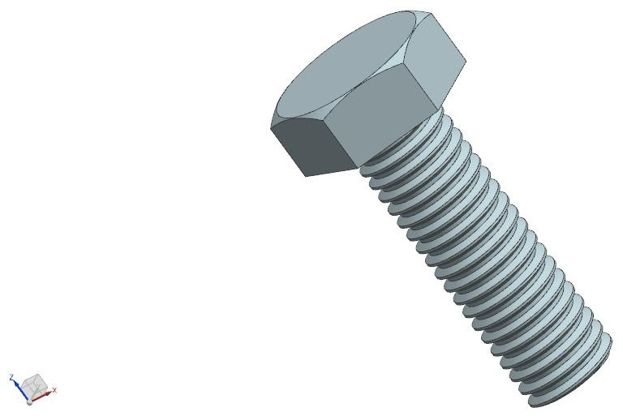  External hexagonal screw M 8*25  2 | ⑾ | 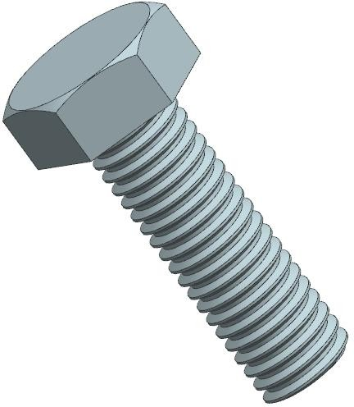  External hexagonal screw M 8*20  6 | ⑿ | Spring pad D8 14
⒀ | Flat pad D 8 14 | ⒁ |  | ⒂

Schematic diagram of bracket position installation (left and right symmetry):
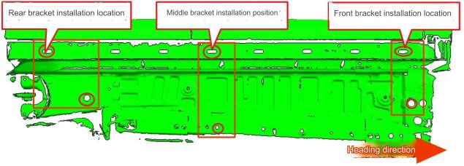
Driving side bracket installation accessories diagram (left and right symmetry):

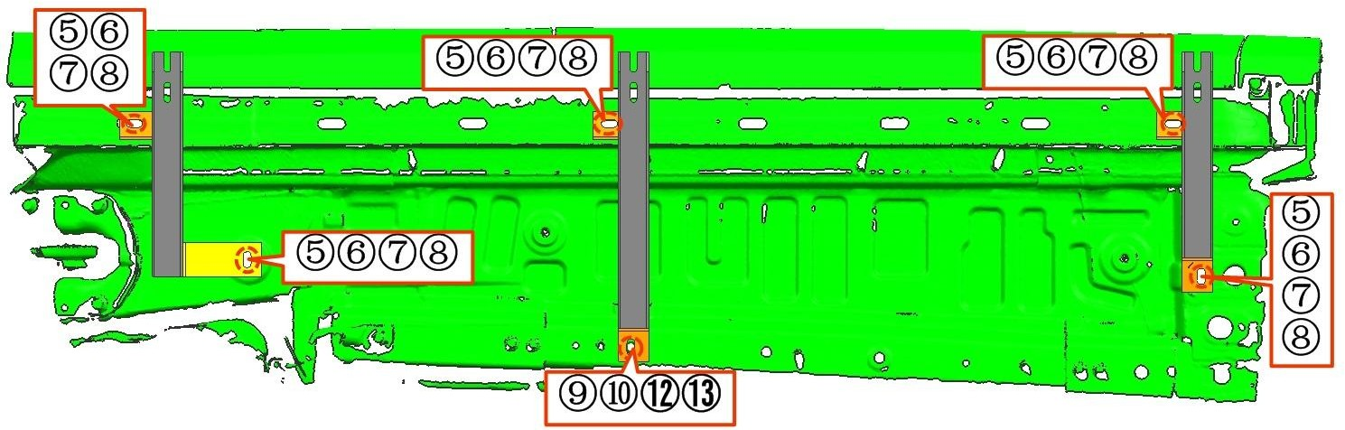
Schematic diagram of pedal/transmission structure installation (left and right symmetry) 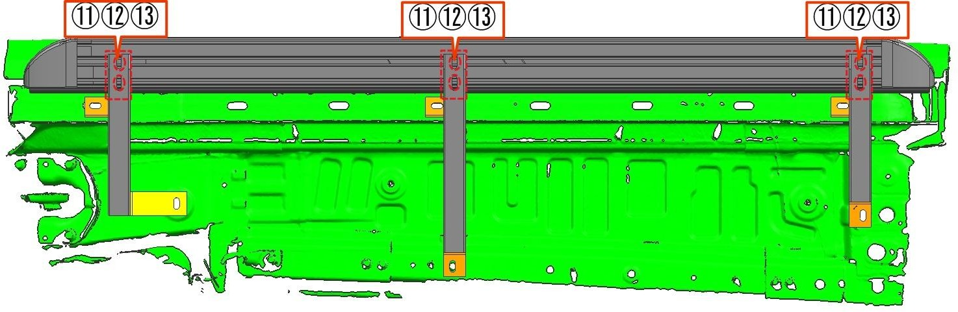

Disclaimer: Related problems caused by improper installation and improper installation are not covered by our company's warranty.

