INSTALLATION INSTRUCTION

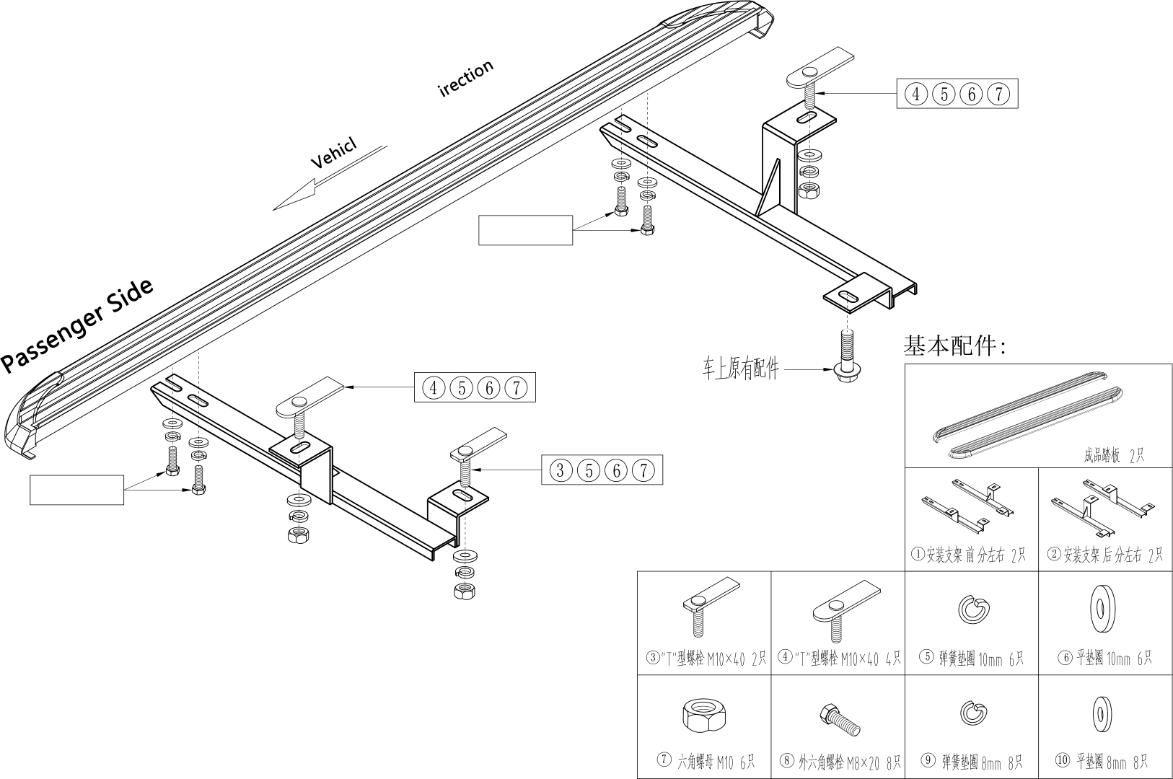

Model: Changan CS35, CS35PLUS