Инструкция по установке порогов Jaecoo J8 / Chery Tiggo 9 (24-)
Accessories List:

 | 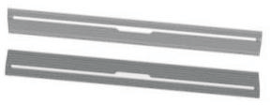  Pedal (symmetrical left and right) 2 pieces |  | 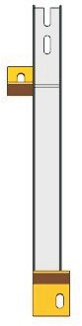  Right front bracket  2 (symmetrical on both sides) |  | 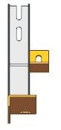  Right middle bracket  2 (symmetrical on both sides)
 | 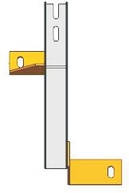  Right rear bracket  2 (symmetrical on both sides) |  | 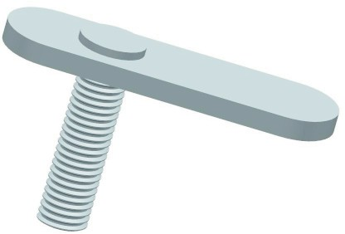  Welding flat head screw M10 * 35 (small) 2 pieces |  | Welding flat head screw M10 * 35 (large) 6 pieces
 |   Elastic pad D10 8 pieces |  |   Flat pad D10 8 pieces |  | 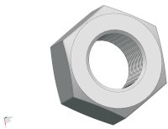  Outer hexagon nut M10 8 pieces
 | 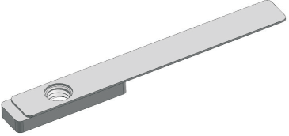  Rectangular nut block M8 2 pieces |  | 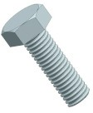  Outer hexagon screw M8 * 25 4 pieces |  | Outer hexagon screw M8 * 20 12 pieces
 |   Flat pad D8 16 pieces |  | 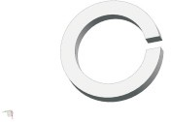  Elastic pad D8 16 pieces | 

Installation diagram of bracket position (symmetrical on both sides):
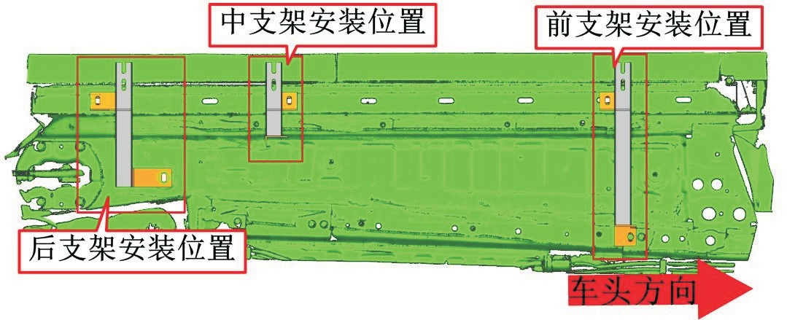
Installation position of front bracket
Front direction
Installation position of rear bracket
Installation position of intermediate bracket

Installation accessory diagram of driving side bracket (symmetrical on both sides)：
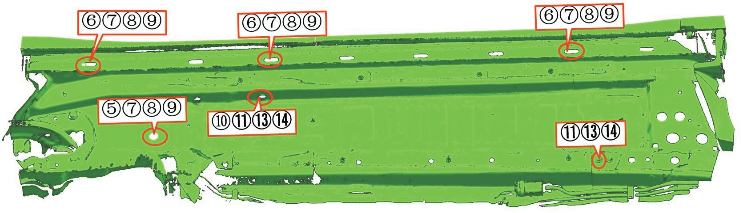

Installation diagram of pedal/transmission structure (symmetrical on both sides)：
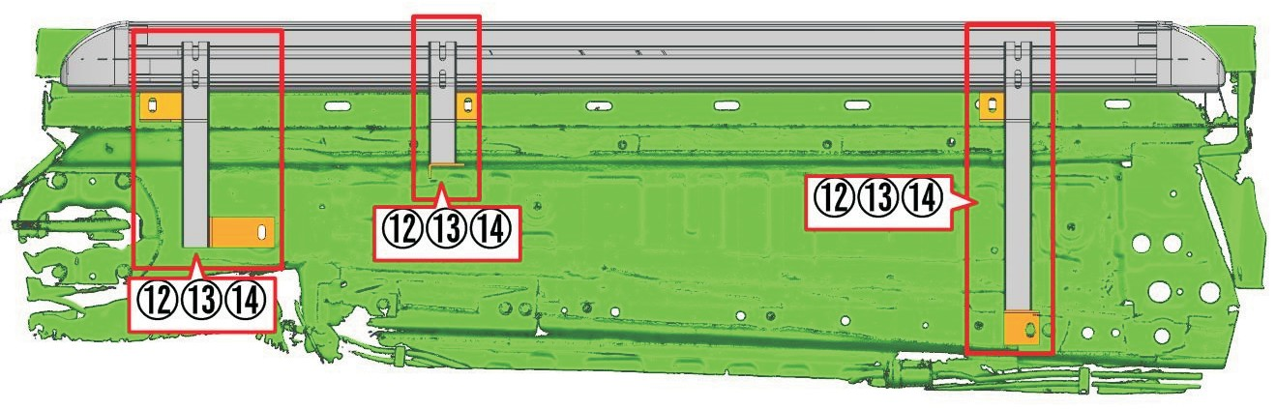
Disclaimer: Any issues arising from installation or improper handling are not covered by our company's warranty

