Инструкция по установке порогов Changan UNI-T
1. All pictures in this manual are for reference only. The pictures may be different from the actual product, but the installation method is the same.
2. To facilitate your installation, please read the product manual carefully before installation. During installation, please protect the surface of your car to avoid scratches.
3. Regularly check whether all accessories connected to the vehicle are loose to ensure safe use.

- Accessories List
SN# | Accessories | Qty | SN# | Accessories | Qty
⑴ | 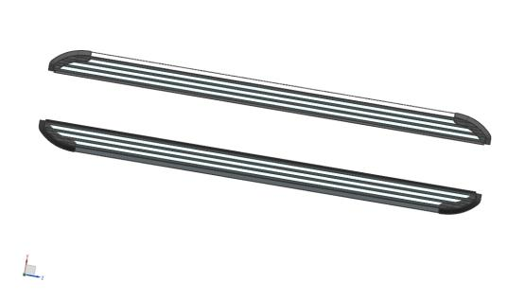  Pedals (symmetrical) | 2 | ⑵ | 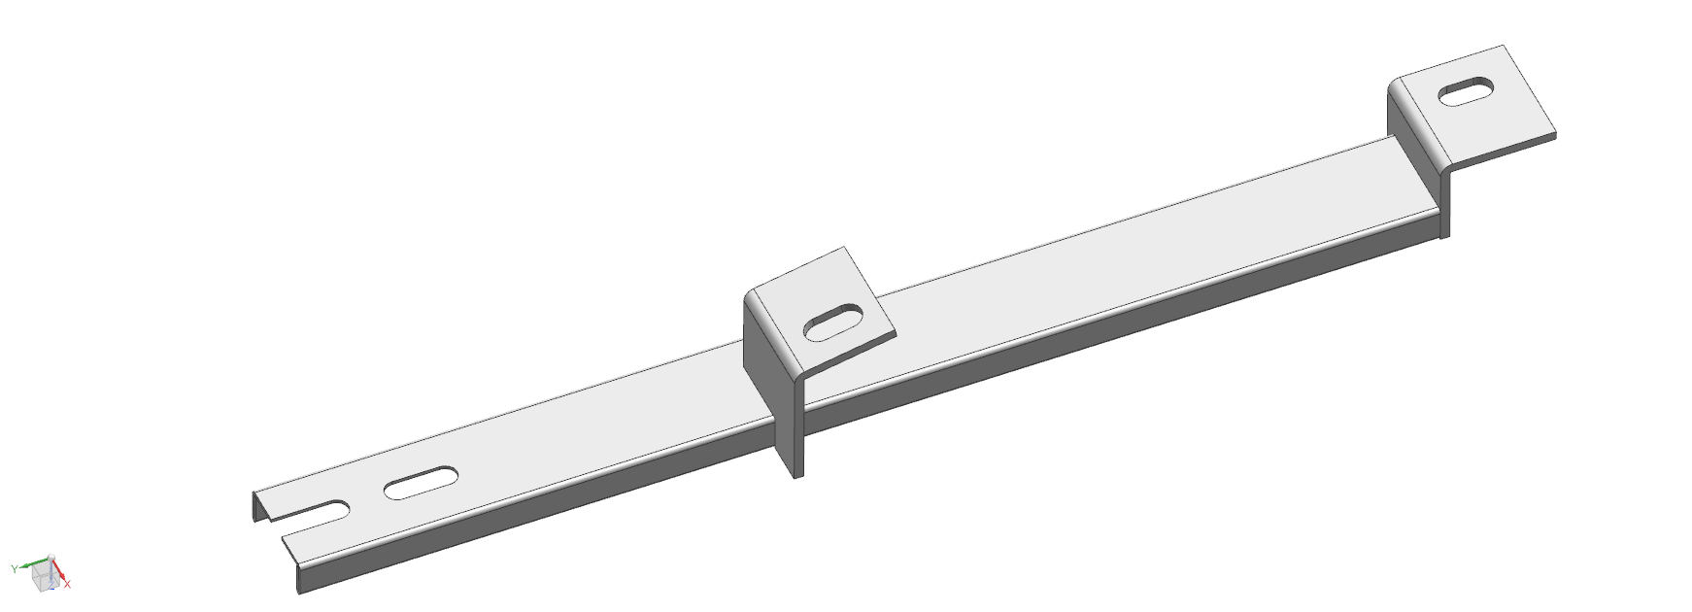  Right front bracket | 2
⑶ | 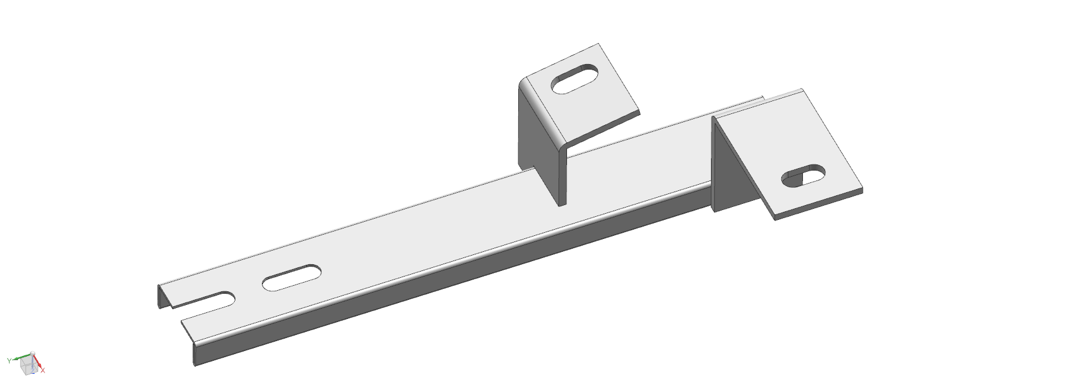  Right middle bracket | 2 | ⑷ | 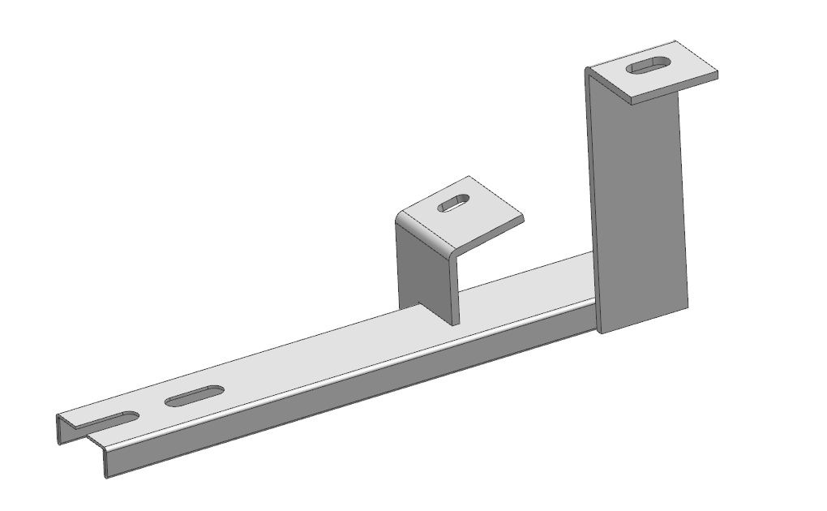  Right rear bracket | 2
⑸ | 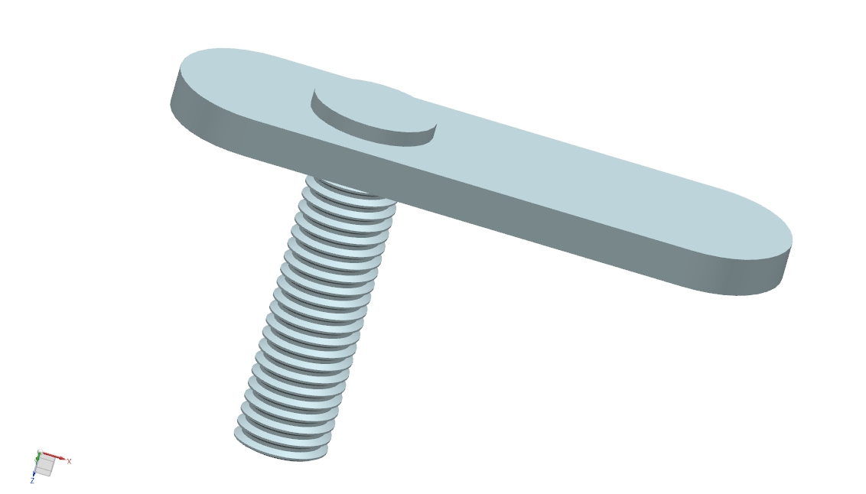  Welding flat head screw M10 | 8 | ⑹ | 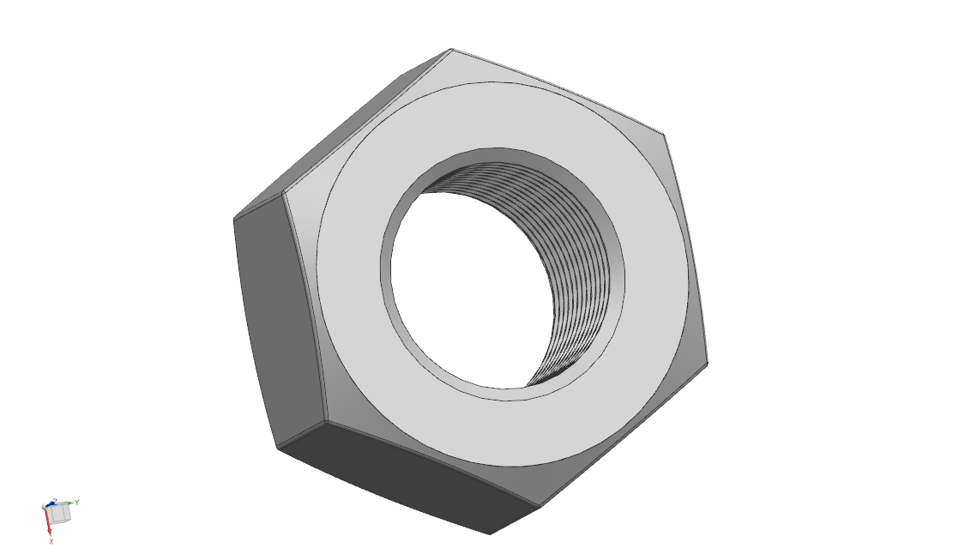  Hexagon nut M10 | 8
⑺ | 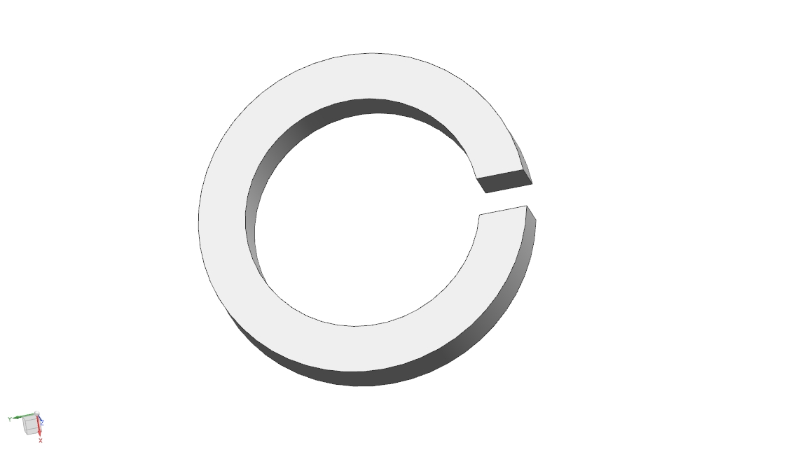  Spring washer ￠ 10 | 8 | ⑻ | 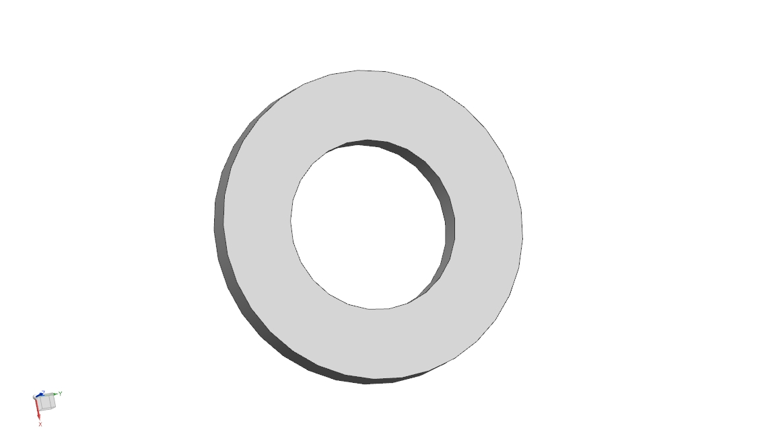  Flat Washer D10 | 8
⑼ | Welding flat head screw M 8 | 2 | ⑽ | Spring washer ￠ 8 | 14
⑾ | External hexagon nut M 8 | 2 | ⑿ | 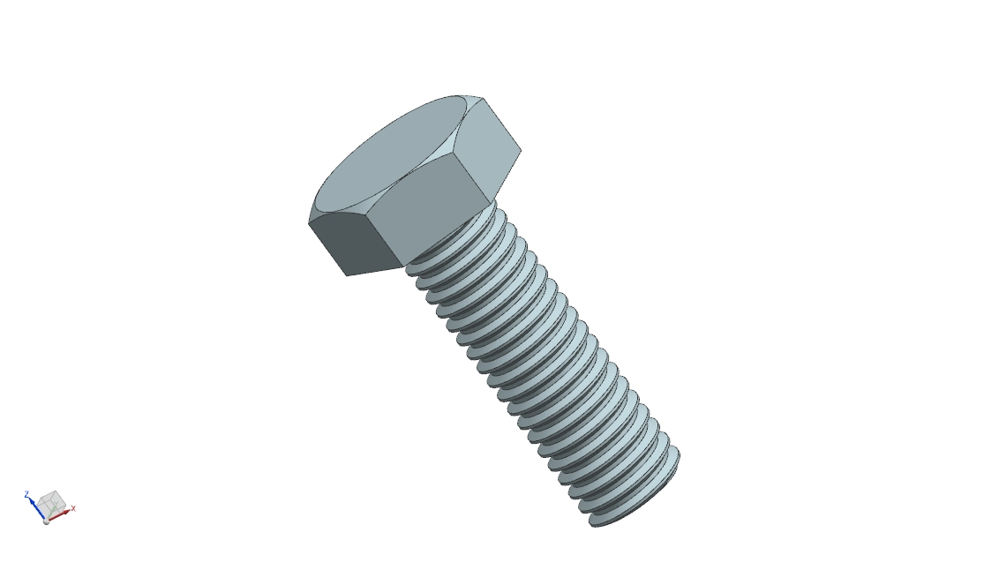  Hexagon screw M8X 20 | 12
⒀ | Flat Washer D 8 | 14 | ⒁ | Hexagonal screw M 6 X 20 | 2
⒂ | Flat Washer D 6 | 2 | ⒃ | Spring washer ￠ 6 | 2

- Installation steps (the installation methods on both sides are the same, only one side is described here)
- Bottom mounting hole diagram:
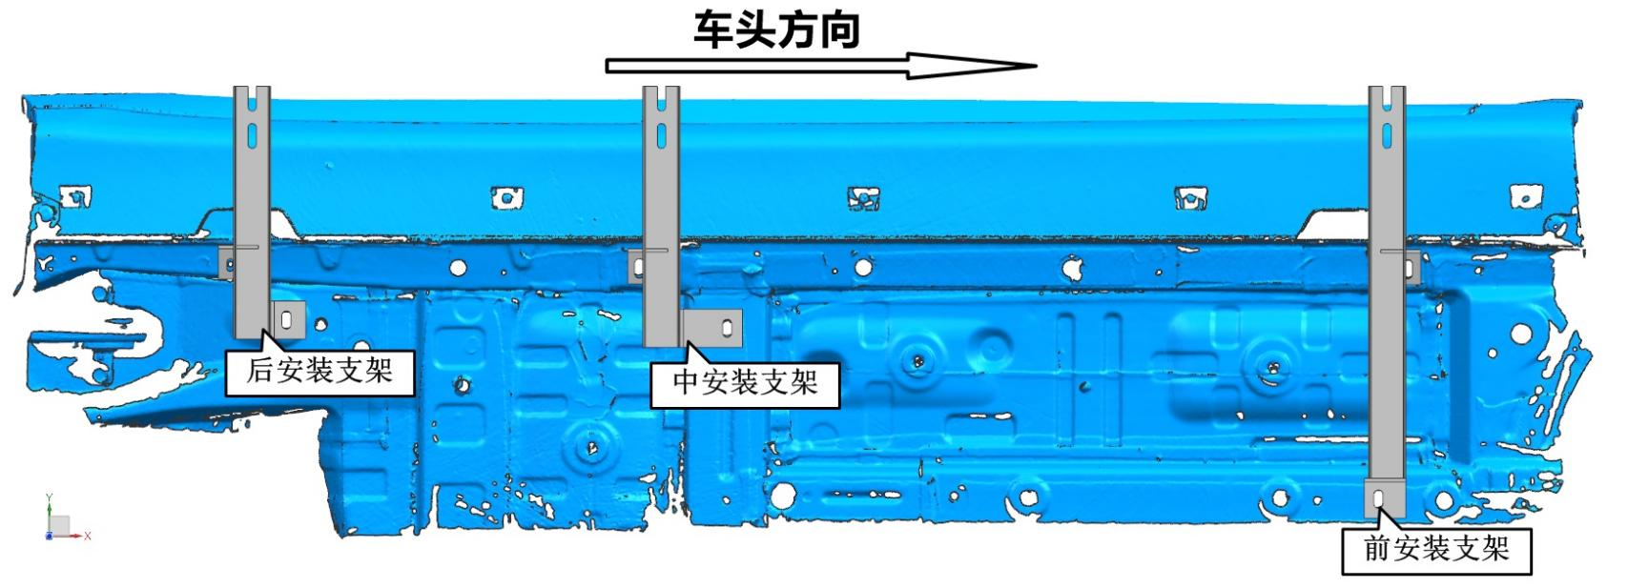
Vehicle Heading Direction
Rear Brackets
Middle Brackets
Front Brackets

- Install the fixed bracket: first remove the original car guard plate, remove the corresponding screw plugs of the original car, then place the welding flat head screws in the corresponding holes, and install the corresponding bracket to lock it. (The installation method is the same for the left and right sides)

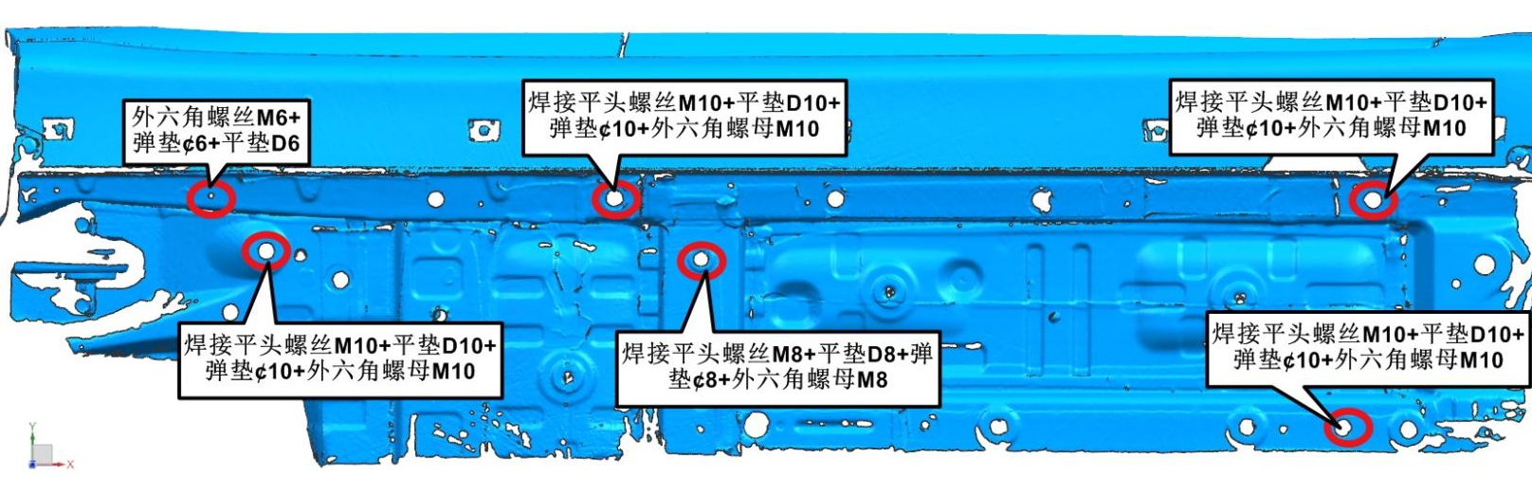

(3) Install the pedals (the installation method is the same for both left and right pedals)
After the fixing bracket is installed, place the pedal on the fixing bracket and lock it with the hexagon screw M8, flat washer D8 and spring washer D8 at the upper hole.
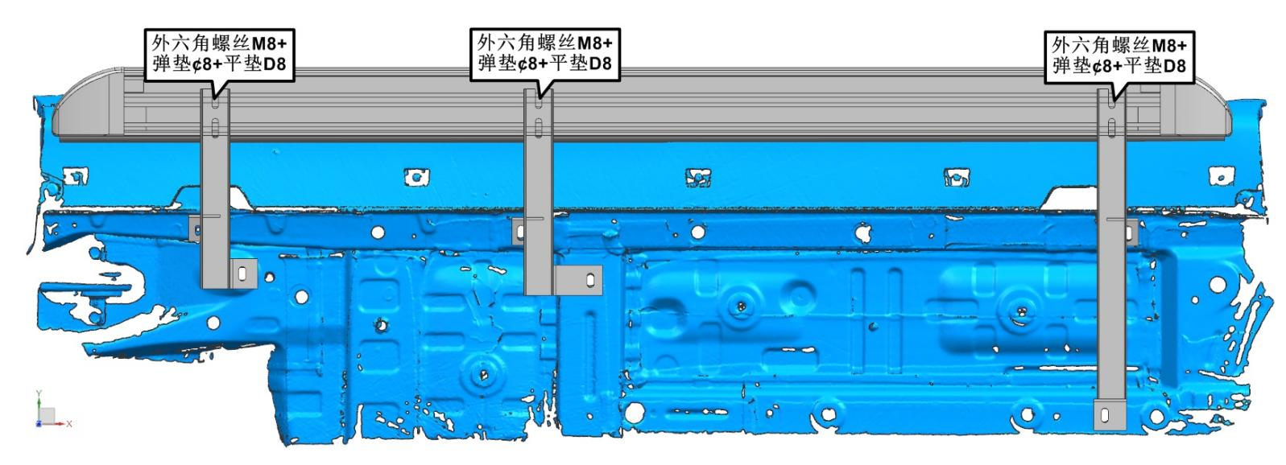
4. Pedal test
- Visually check whether it is parallel to the vehicle body.
- After confirming that the pedal is completely OK, do not forget to check whether the nut on the pedal is fully tightened. After the nut is fully tightened, finally install the original vehicle guard plate. If there is interference between the bottom guard plate and the pedal bracket, please trim the interference between the bracket and the original vehicle guard plate to ensure that the original vehicle guard plate is successfully installed. After completing the installation, you can experience the brand new visual effect and convenience of getting on and off the car after the modification.

