Инструкция по установке порогов
Haval F7 (ShenShou) 2024-
Accessories list :
⑴ | 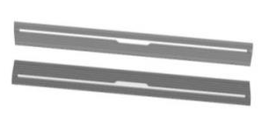  Pedals (symmetrical)  2 | ⑵ | 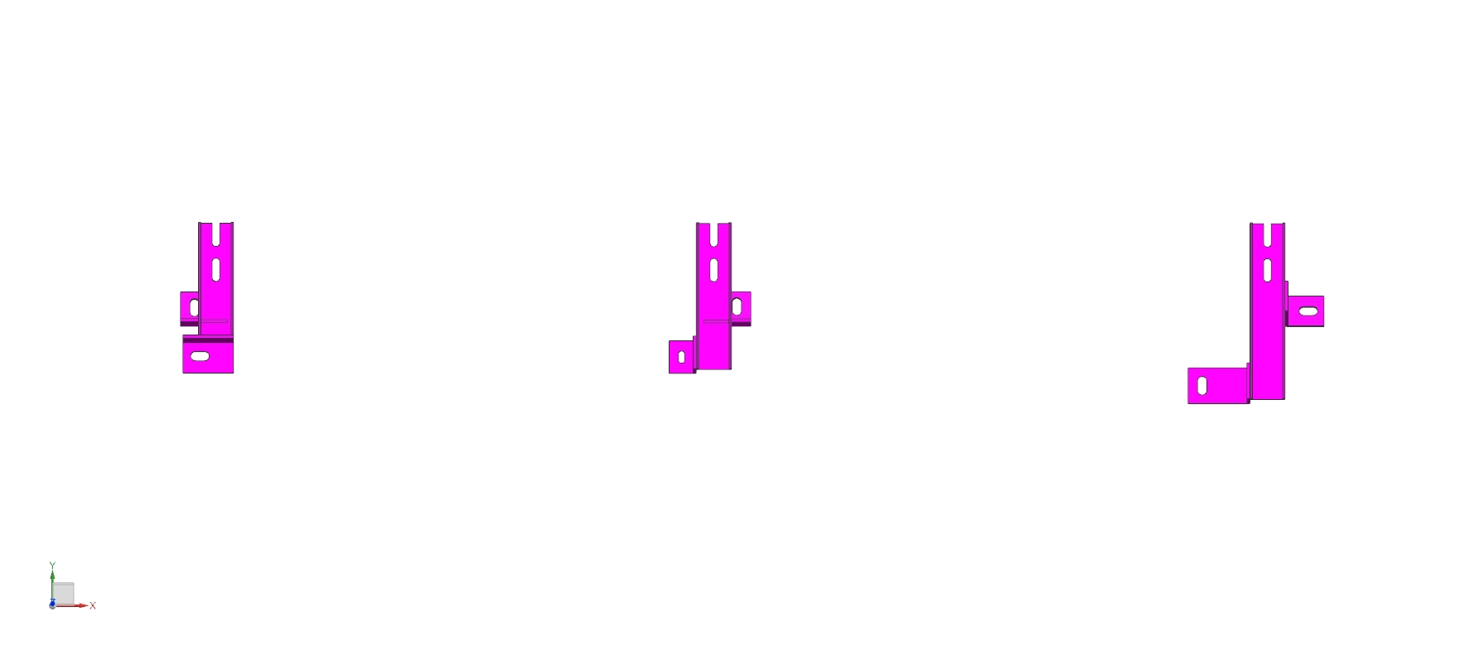  Left front bracket  2 (symmetrical) | ⑶ | Left center bracket  2 (symmetrical)
⑷ | Left rear bracket  2 (symmetrical) | ⑸ | 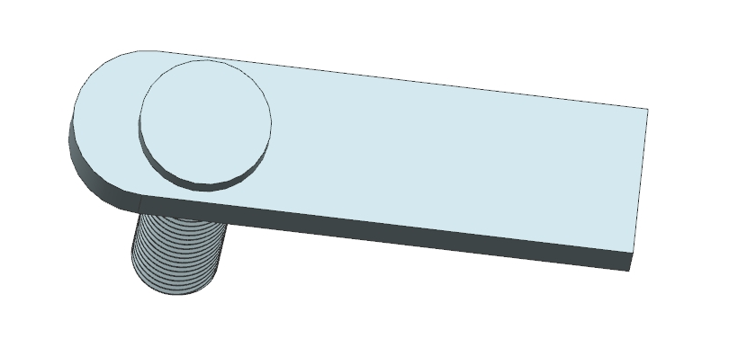  T-bolt M10X35 (large)  2 | ⑹ | T-bolt M10X35 (small)  8
⑺ |   Flat Washer D 10  10 | ⑻ | 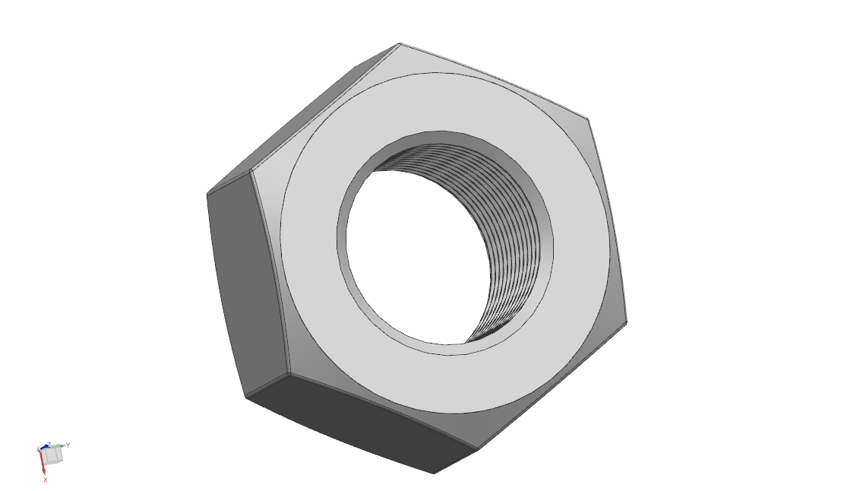  External hexagon nut M 10  10 | ⑼ | 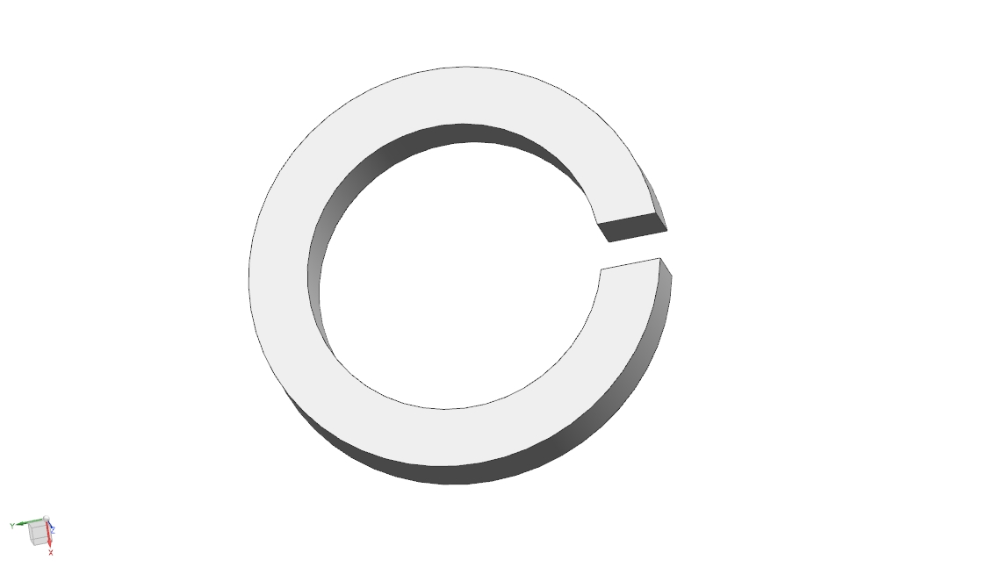  Spring washer D10  10
⑽ | 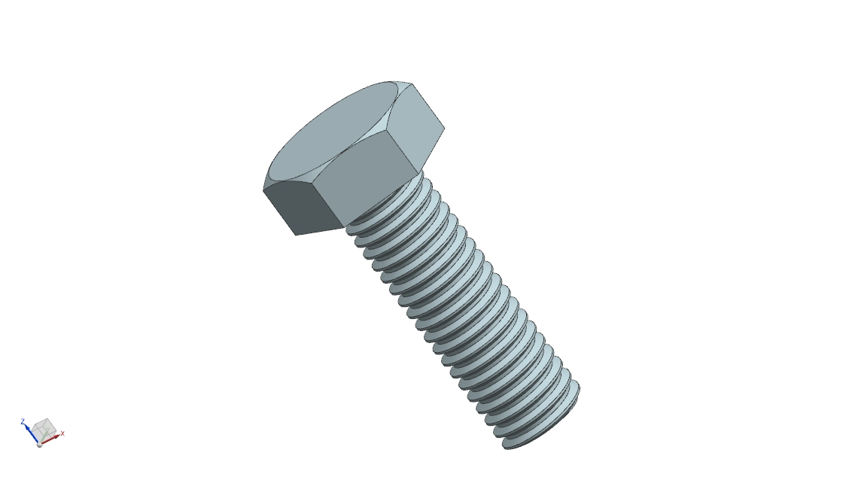  Hexagonal screw M 8X20  12 | ⑾ | Flat Washer D 8  12 | ⑿ | Spring pad 8  12
⒀ | Hexagonal screw M 6X20  2 | ⒁ | External hexagon nut M 6  2 | ⒂ | Flat Washer D 6  2
Bracket installation diagram (left-right symmetry):
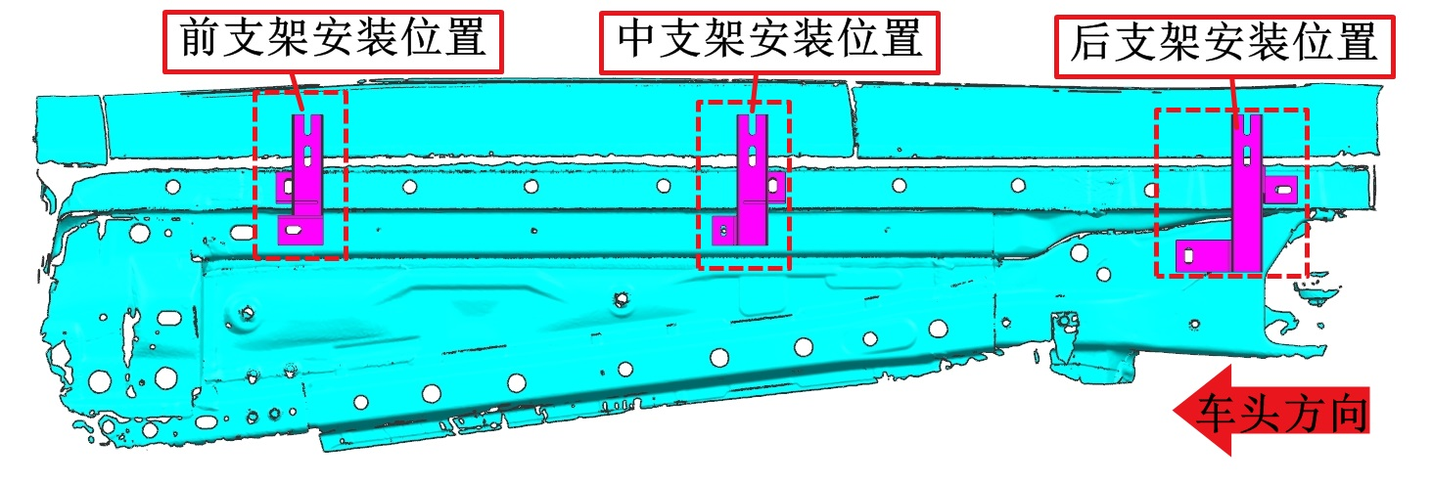
Front Bracket
Middle Bracket
Rear Bracket
Vehicle Heading Direction
Driver side bracket installation accessories diagram (left-right symmetry):
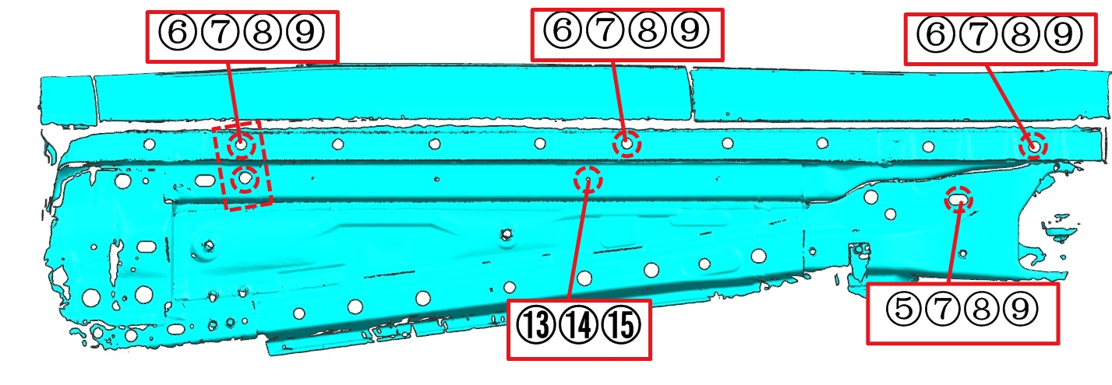
Pedal/transmission structure installation diagram (left-right symmetry):
