Инструкция по установке порогов
Geely Cityray (2024-) / Boyue Cool (2023-)

⑴ | 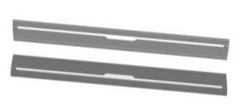  Pedals (symmetrical)  2 | ⑵ | 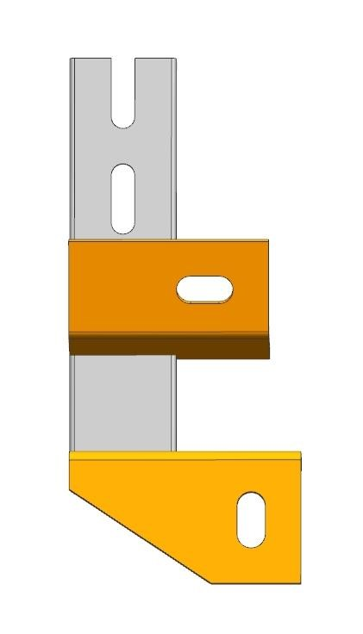  Left front bracket  2 (symmetrical) | ⑶ | 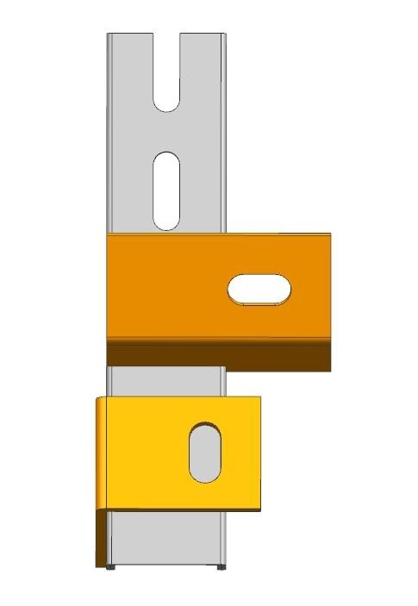  Left center bracket  2 (symmetrical)
⑷ | 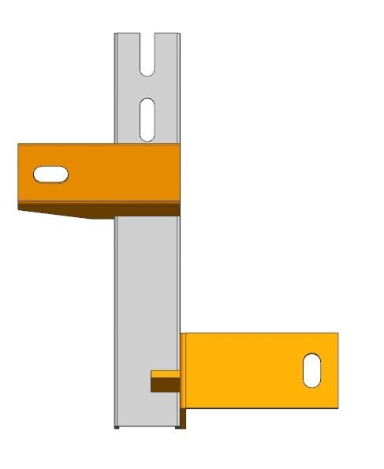  Left rear bracket  2 (symmetrical) | ⑸ | 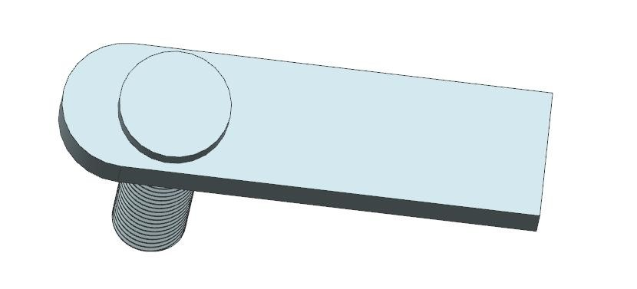  Welding flat head screw  M10X35 (large) 4 | ⑹ | Welding flat head screw  M10X35 (medium) 2
⑺ | Welding flat head screw  M10X35 (small) 6 | ⑻ | 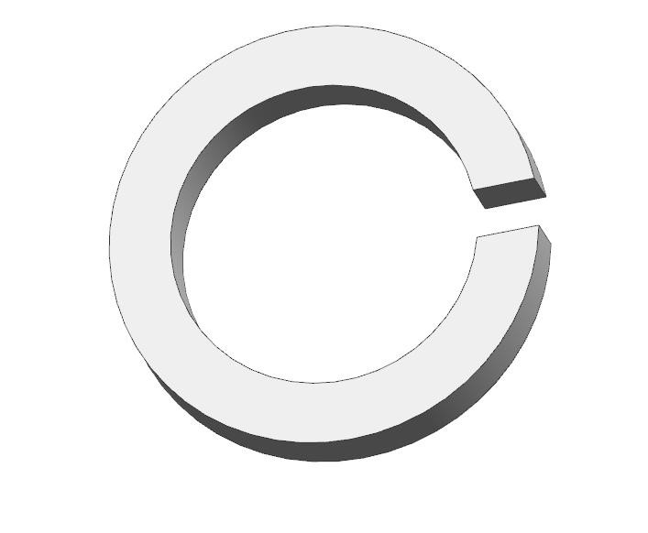  Spring washer D10  12 | ⑼ | 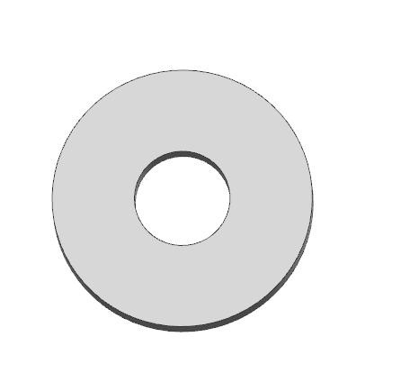  Flat Washer D 10  12
⑽ | 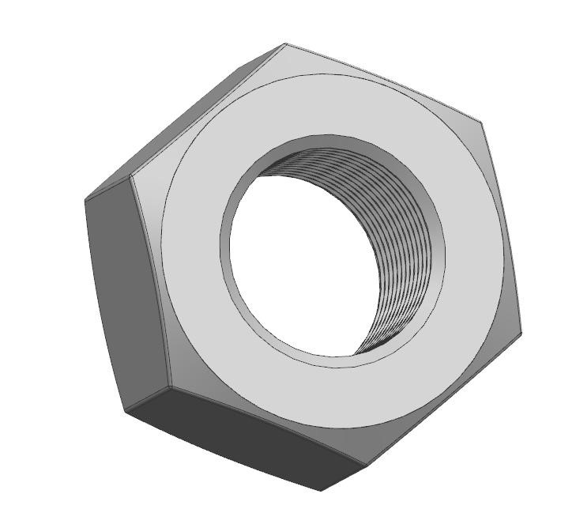  External hexagon nut M 10  12 | ⑾ | 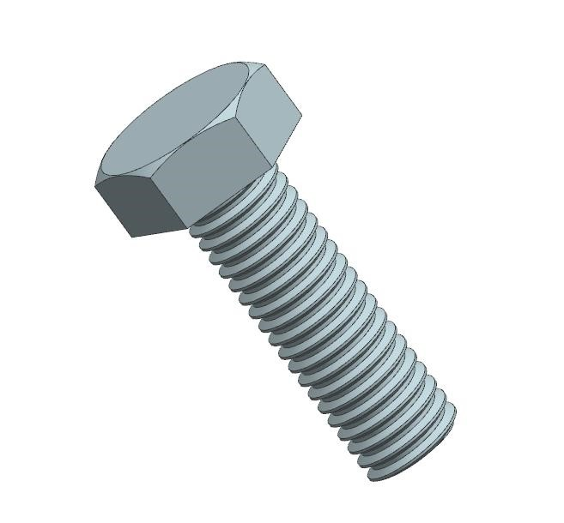  Hexagonal screw M 8X20  12 | ⑿ | 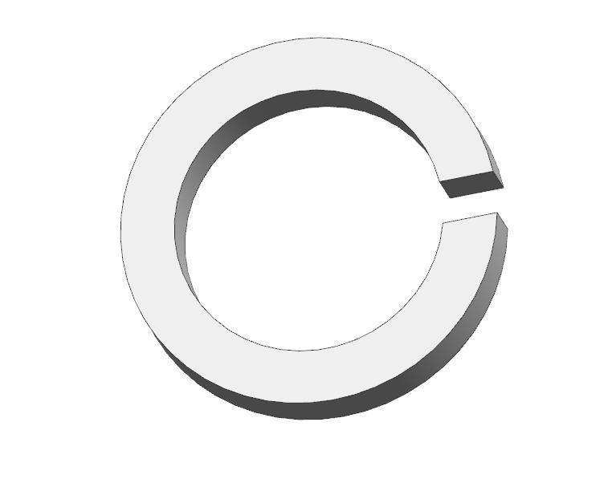  Spring washer D8  12
⒀ | Flat Washer D 8  12 | ⒁ |  | ⒂
Bracket installation diagram (left-right symmetry)
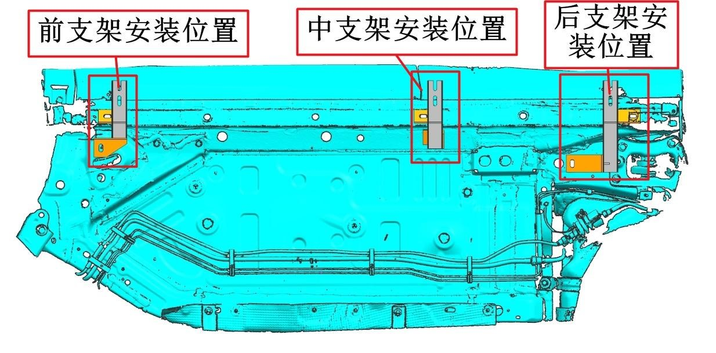
Front
Bracket
Middle
Bracket
Rear
Bracket
Driver side bracket installation accessories diagram (left-right symmetry):
